Pre-registration:

The Role of Attention in eye movement Awareness

*Aoife Mahon*, Alasdair D. F. Clarke* & Amelia R. Hunt\**

*\*School of Psychology, University of Aberdeen*

# Abstract

Draft of introduction and Experiment 1. Pre-registration of Experiment 2, with example analyses carried out on pilot data.

# Introduction

The visual world is enriched with far more information than we can possibly process. Both eye movements and attention are involved in the process of selectively sampling information from the visual array for more detailed processing, to the exclusion of other information. This functional similarity has led to the intuitively appealing hypothesis that covert attention and eye movements exist on a continuum, with covert attention representing a kind of sub-threshold eye movement (Klein, 1980; Rizzolati et al., 1987). This hypothesis has been supported by research demonstrating that covert attention is allocated to the location where an eye movement is about to be executed (e.g. Shepherd, Findlay and Hockey, 1986; Hoffman and Subramaniam, 1995). Although it is possible to deploy covert attention in the absence of an eye movement, it is generally thought to not be possible to move the eyes without also moving attention. This conclusion has been reinforced by many studies demonstrating the obligatory nature of the coupling of attention to eye movement execution (many refs).

If eye movements necessarily recruit and involve attention, one might expect people’s awareness of their own eye movements to be reasonably high. However, previous research on eye movement awareness suggests this awareness is extremely limited. … [describe Clarke, Mahon, Irvine and Hunt, 2016]. Based on these results, we reached the conclusion that people have many strategies at their disposal to boost accuracy when asked to report on their own eye movements, but when these strategies are not available, the accuracy of reports is close to chance. This is consistent with previous studies in which alternative strategies were available, which found people to be moderately above chance in their ability to report on their own eye movements (Foulsham and Kingstone, 2013; Marti et al., 2015).

In contrast to goal-directed eye movements, involuntary exogenous movements are generally triggered by a sudden or abrupt event, independent of the observer’s goal. As these movements may disrupt the execution of pre-planned endogenous saccades, and the completion of a goal, it could be expected that individuals should have more awareness of these, especially if they occur as an error. Two paradigms in particular have been used to examine awareness of erroneous exogenous saccades: the anti-saccade and oculomotor capture tasks. Mokler and Fischer (1999) examined the recognition, and correction, of involuntary prosaccades executed during an antisaccade task. Previous research indicated that when required to produce an antisaccade, i.e. saccade to the opposite side of an onset target, participants produced incorrect prosaccades to the target (Halle, 1978; Fischer & Weber, 1992) of which they were generally unaware, even when the onset target was precued (Fischer & Weber, 1996). In their experiment participants were required to indicate on a trial-by-trial basis, across 36,767 trials, whether they made a correct antisaccade or incorrect prosaccade to the onset target. On average, they report participants did not recognise errors in 50+/-25% of trials.

Theeuwes and colleagues (1998, 1999) developed an oculomotor capture design to investigate erroneous eye movements executed towards abrupt or sudden onsets but also indirectly looked at the effect of this on eye movement awareness. Participants were shown a preview of six grey circles arranged in a circle, each with a premask figure-eight at the center. After 1,000ms the 8’s changed to letters and all the circles changed to red except for one circle which remained grey (the colour singleton). Participants were instructed to execute a saccade towards the colour singleton and to determine if the letter, a *c*, was presented facing forwards or in reverse. On half of the trials, with the onset of the colour change, an additional red circle appeared at random between the existing circles. In Theeuwes et al. (1999) a control condition was used which included an additional non-onset distractor displayed at the beginning of the trials. Both studies found that the eyes were captured by the sudden onset target on 30-40% of trials. Oculomotor capture occurred most frequently when the onset was presented at 30 degrees from the target. These results, under different experimental conditions, have been replicated many times (e.g., Belopolsky et al. 2008; Born et al. 2011; Godijn and Theeuwes 2002b, 2003; Hunt et al. 2007; Wu and Remington 2003). At the end of their experiment Theeuwes et al. (1998) asked participants if the sudden onset affected their eye movement behaviour. It was reported that most were not aware of an abrupt onset and no participants reported that their eye movements were affected or captured by it. As participants were only asked at the end of the experiment it could be argued that individuals may no longer have access to this information.

Belopolsky, Kramer and Theeuwes (2008) similarly used an oculomotor task. In their experiment the distractor was presented on 75% of trials with an onset grey premask presented on the remaining trials. The distractor onset was limited to 90 or 150 degrees from the colour singleton target. After each trial participants were asked if they looked directly to the target and to rate their confidence in their response. They found that on nearly two-third of trials participants executed correct movements. In 16% of trials participants looked at the onset, correctly reporting this around two-thirds of the time. Of trials where observers looked at a circle other than the target or onset, which occurred on 19% of trials, participants only reported that their eyes were captured on 5% of these. Although results vary these studies generally suggest that people have limited awareness of their own eye movements, even when they are aware they will be asked to report on them or when these movements occur as an error and negatively impact their performance.

While the above studies looked at eye movement awareness regarding endogenous and exogenous saccades participants may be reporting covert shifts of attention as opposed to eye movements. Abrupt salient sudden-onset targets capture not only our eyes (e.g. Theeuwes et al., 1998, 1999) but also our attention (e.g. Yantis & Jonides, 1984; Jonides & Yantis, 1988; Theeuwes, 1994, 1995, 1999). Godijn and Theeuwes (2002) demonstrated that inhibition of return effects were seen even if the eyes were not captured by a sudden onset target, suggesting that although oculomotor capture had not occurred, attentional capture had. The oculomotor capture paradigm, in fact, grew from a previous paradigm developed by Theeuwes (1991a, 1992, 1994), commonly refereed to as the ‘irrelevant singleton‘ (Yantis & Egeth, 1999) or ‘additional singleton’ paradigm (e.g., Simons, 2000). Similar to the oculomotor design, an irrelevant distractor singleton is shown with a relevant target singleton. If the distractor has captured the participant’s attention they produce slower reaction times towards the target singleton compared to no distractor trials (Theeuwes, 1991; 1992; 1994; 2000; Theeuwes & Godijn, 2001). Attention is allocated exogenously to the distractor singleton before it can be allocated to the target singleton causing increased reaction times. This finding was further demonstrated by Theeuwes (1996) by manipulating the congruency of a character presented at the distractor and target singletons. Trials were divided into no distractor, congruent meaning the character presented at the distractor location matched the target and incongruent meaning the opposite. Incongruent trials were significantly slower than congruent, suggesting the target within the distractor target was processed demonstrating the allocation of spatial attention. Although the additional distractor influences participant’s performance by slowing their reaction times, participants still report very little awareness, often not noticing the irrelevant target had been presented (Yantis, 1993; Kramer et al., 2000; Belopolsky et al., 2008). In everyday circumstances a lack of awareness to sudden onsets within our environment can have detrimental effects. Are individuals not aware of attentional capture even if it impacts our behaviour?

The present study will present three experiments assessing the role of oculomotor capture and attentional capture of eye movement awareness as well as the influence of pre-determined knowledge of both on awareness. All three experiments use a variation of the oculomotor paradigm used by Theeuwes et al., 1998 and Theeuwes et al., 1999. In Experiment 1 we looked at the influence of oculomotor capture on self-reported eye movement accuracy by presenting an abrupt onset distractor on half of the trials, simultaneously with the presentation of the target colour singleton which had a discrimination target presented within it. After each trial participants reported whether they had executed a correct eye movement or not. Experiment 2 looked the influence of attentional capture on eye movement awareness. Do covert shifts of attention cause participants to think they executed eye movements?

General Methods

## Set-up

The research presented was [or will be] conducted in the Eye Movements and Attention laboratory at the University of Aberdeen. Experimental scripts were created and run using MatLab with the PsychToolBox (cite) and run on a PowerMac 10.8.2. Stimuli were presented on a Sony Trimaster EL computer screen, 1080 x 1920. Participant responses were recorded using an Apple keyboard with numeric keyboard. Eye-tracking across all three experiments was conducted using the EyeLink 1000.

## Participants

Participants included students and academic staff at the University of Aberdeen. All experiments were conducted with the full understanding and signed consent of each participant and were approved by the Psychology Research Ethics Committee, University of Aberdeen. All participants had normal or corrected-to-normal vision. In Experiment 1 naïve participants were remunerated £5 for their time. *No participants took part in multiple experiments.*

## Analysis

We have chosen to follow recent advice from Cumming (2013) on the reporting of results in psychology research. Namely, we will avoid using *p*-values and null-hypothesis significance testing wherever possible. We expect to find a range of abilities for different observers, and our aim is to measure and report that range under different tasks and conditions. Where appropriate, we use general linear mixed-effect models (from the ***lme4*** package for ***R Version 3.2.3***) to estimate effect sizes and standard errors while factoring our random effects associated with differences between individual observers and images. 95% confidence intervals will be obtained by bootstrapping using the ***confint*** function.

In both experiments, participants are required to provide binary responses about whether their eye movement was “good” or not. As such we will be using the classification technique used in Clarke, Mahon, Irvine and Hunt (2016). A simple accuracy measure such as percent correct is not suitable for characterising performance, because individual participants may have a response bias that could run the same or the opposite way of the bias in what is the correct response. For example, if there is a general bias to say yes to the question of whether or not participants say they made correct eye movements we should be able to counterbalance this. This method provides a more appropriate measure of how well people can discriminate their accurate from their inaccurate eye movements. Hence we will present our results using two statistics commonly used in the classification literature: precision and recall. If we are trying to classify A from B, then the definitions are as follows:

• Accuracy: the proportion of all items successfully classified.

• Precision: the proportion items classified as A that are actually A.

• Recall: the proportion of items belonging to class A that are classified as A.

# Experiment 1: Oculomotor Capture

It has been suggested that participants in oculomotor capture experiments are not aware of their eyes persistently being misdirected towards irrelevant sudden onsets when instructed to look at a color singleton (reference). This was originally based on subjective reports collected from simply asking participants during debriefing if they were aware of their errors during the experiment (Theeuwes et al., 1998). More recently Belopolsky, Kramer and Theeuwes (2008) conducted an oculomotor task in which they asked participants if they looked directly to the target after each trial. Participants correctly reported looking at the distractor target on around two-third of trials however if participants executed an erroneous movement to a circle other than the target or distractor they correctly identified these errors in 5% of trials. Within this study distractor onsets were limited to 90° or 150° from the colour singleton. It has been previously shown that oculomotor capture occurs most when the distractor is presented at 30° from the colour singleton however this location and others were not examined. Experiment 1a sought to gather a more precise and immediate estimate of how aware participants are of their own erroneous saccades. If participants are truly unaware their eyes being captured, as the Theeuwes et al (1998) anecdotal reports suggest, then participants should identify the vast majority of the trials as “good”, even when the eyes were misdirected to the irrelevant onset.

Experiment 1b aimed to examine the effect of distractor awareness on oculomotor capture and eye movement awareness. Kramer, Hahn, Irwin and Theeuwes (2000) found that the interference caused by distractors was reduced if participants were aware of to-be-ignored information. In their study distractors appeared as equiluminant to the target, making them unaware to the participant or more salient than the target, allowing participants to become aware of the distractor. In younger adults, being aware of the distractor reduced oculomotor capture, with the result being reversed in older adults. They suggested awareness of the distractor allowed participants to actively inhibit the target, a process requiring working memory, which can decline with age explaining the difference in scores. The attentional white bear phenomenon (Lahav, Makovski & Tsal, 2012, Tsal & Makovski, 2006) has however gone on to show that in order to inhibit an object we must first attend it and as such awareness of to-be-ignored distractors will negatively affect performance in oculomotor tasks. Chisholm and Kingstone (2014) directly investigated the influence of awareness on oculomotor capture by manipulating the information given to participants prior to completing an oculomotor experiment. They had three groups; participants who were told that a distractor would appear (aware), a group where they were provided with no information regarding the distractor (unaware) and a third group where participants were informed that a distractor would appear and were instructed to avoid being captured by it (avoid group). Participants within the aware group had the lowest level of oculomotor capture. They concluded that although some awareness of distractors can benefit performance and help avoid capture (Kramer et al., 2000) over emphasis on the distractors, for example instructing participants to actively ignore them, can hinder performance and increase oculomotor capture.

# Experiment 1: Oculomotor Capture

### **Methods**

### *Participants*

Ten naïve participants (_ females, median age _, range = _ - _ years old, ) took part in the Experiment 1. Two authors of the current paper also participated.

### *Stimuli and procedure*

Each trial began with a single central fixation calibration point on a blank grey screen ensuring participant’s maintained central fixation. Participants were required to press *spacebar* to complete calibration and to begin the trial. Stimuli consisted of six orange circles (radius 32 pixels) (N.B need these in degrees of visual angle) evenly distributed around a central fixation cross, resembling a larger invisible circle, with a radius of 256 pixels. After 1000ms, all but one of the circles changed colour from orange to red. The target circle was defined as the one circle that maintained the original orange colour. A discrimination target (DT), presented as a forwards or backwards *c* appeared inside the target circle. Participants were instructed to look directly and as quickly as possible to the target circle. On half of trials an additional red distracter circle would appear, simultaneously with the colour change, in-between two existing circles. See Figure 1 below for an example. The target and distractor array was displayed for 800ms.

|  |  |
| --- | --- |
| Macintosh HD:Users:s09ac3:Documents:EyeMovementAwareness:AttentionalCapture:preview.png | Macintosh HD:Users:s09ac3:Documents:EyeMovementAwareness:AttentionalCapture:stimulus.png |

***Figure 1***: Example of the preview and experiment stimuli presented on a distractor trial. Six orange circles are presented in a circular array around a central fixation cross, 5 circles change to red, 1 remains orange. Participants must saccade to the orange target and report the direction of the DT inside. As this is a distractor trial an additional red circle is presented between two previously presented circles.

During the experiment after each trial participants were asked, via the computer screen, “Was this a good trial?” Participants responded by pressing a ‘y’ for “yes” or ’n’ for “no” on the keyboard. Before the experiment began, participants were told that we were interested in filtering out trials in which they made eye movement errors. They were instructed that a “yes” response meant that during the previous trial their eyes went from the center of the display directly to the orange circle target, a “no” response was if their eyes did not move *directly* to the target circle. If participants responded “yes”, they were then presented with a second question: to identify if the target *c*, which was presented within the target circle, was facing either forwards or backwards, by typing ‘f’ for forwards or ‘b’ for backwards.

There were six potential target locations and six potential distracter locations, so with three replications, this gave 108 trials. We included an equal number of trials with no sudden onset distracter to give a total of 216 trials.

### **Results**

In Experiment 1 all participants managed to successfully identify the DT, a *c* or reversed *c* presented in the target circle, on at least 95% of the trials. However, participants were less accurate in identifying the trials in which they made a “good” eye movement. To analyse this, we collapse over all target and distracter conditions and categorised trials based on the total path length of the saccades made by the participant during the trial. Path length was normalised so that 1 unit represents the distance from the central fixation cross to the center of the target. We then classed trials in which the total path length was between 1-*a* and 1+*a* as “good” (*a*=0.2 unit). Figure 2 shows the number of trials that were classified as “good” and “bad” for each participant, and within each of these categories the number of trials the participant responded “yes” (good) or “no” (bad). Data from the two participants who took part in Experiment 1b are presented as *A* and *B.*

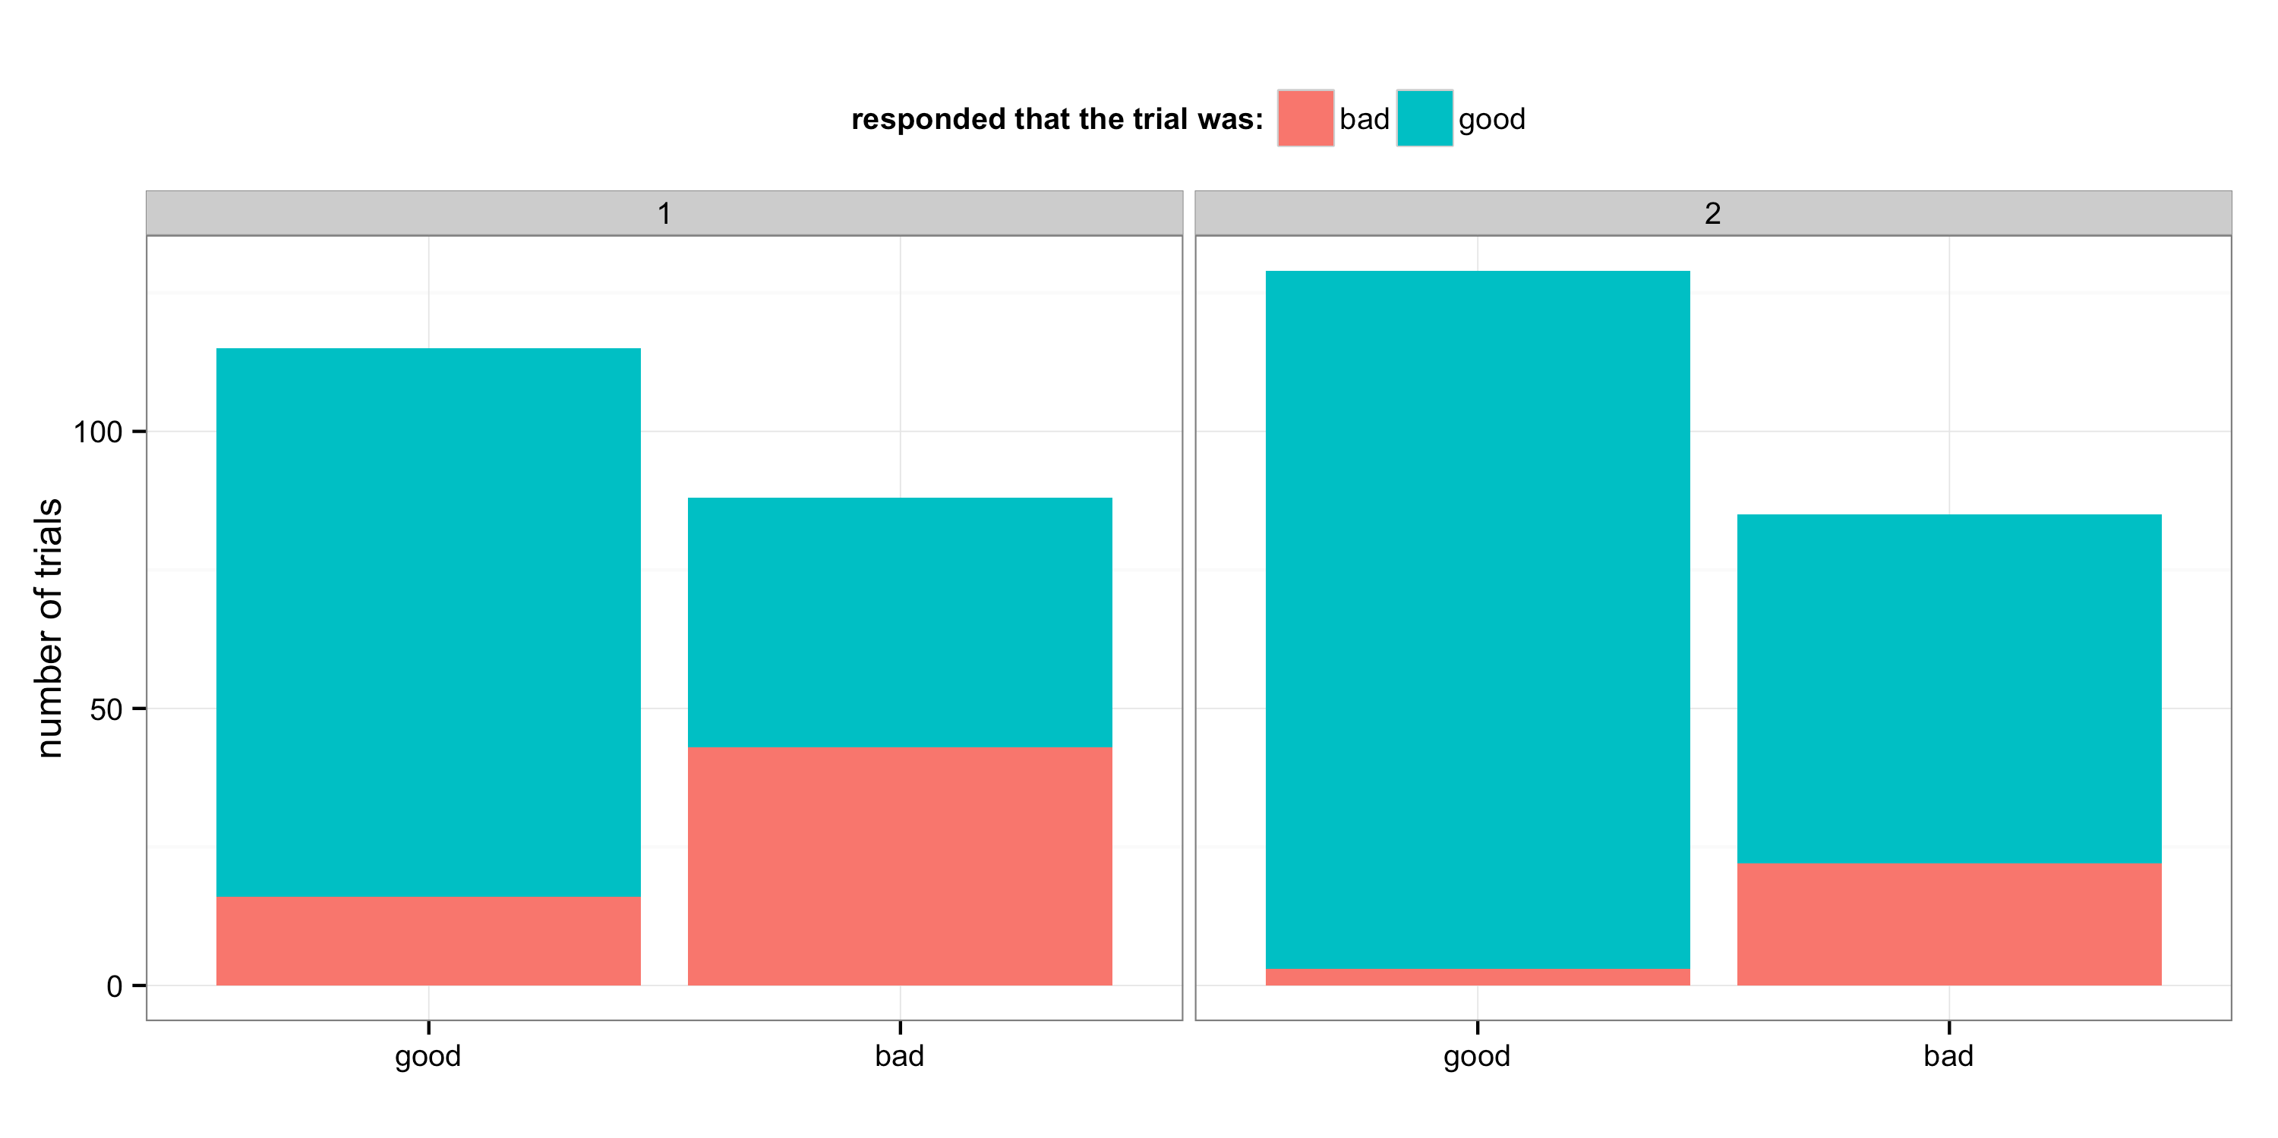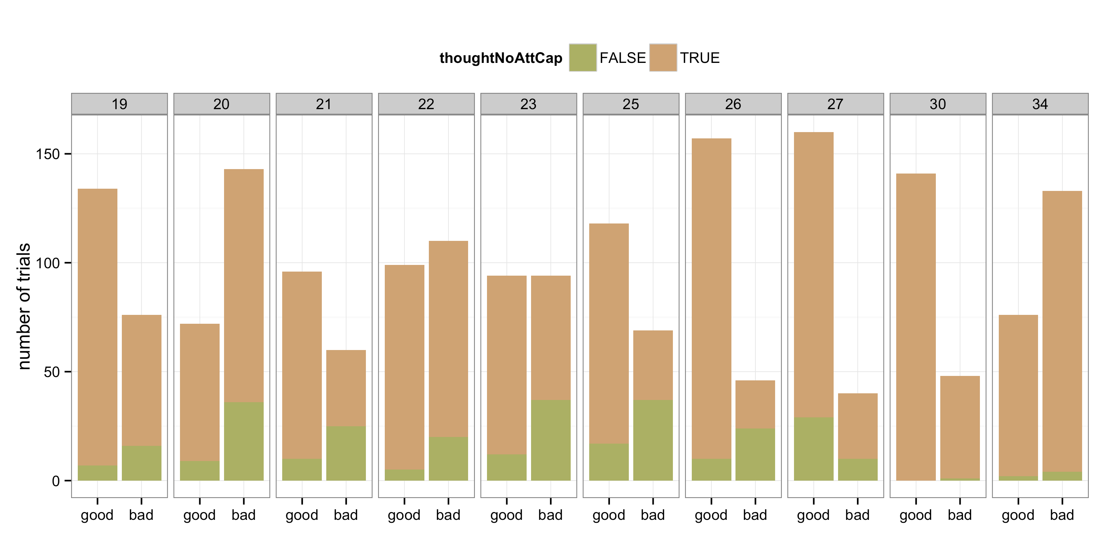

Figure 2: Trials in which “good” and “bad” eye movements were executed by each participant are shown above. Trials in which participants correctly identified as “true”, or incorrectly as “false”, are presented inside the data bars.

It can be seen in Figure 2 that participants in general correctly believed they executed more “good” eye movements compared to “bad”. There are individual differences across participants in terms of not only their ability to inhibit the distractor to execute more correct eye movements directly to the target circle but also in self-awareness of their eye-movements. For the majority of participants, there appears to be very low eye movement awareness, with participants classifying some correctly executed eye movements as “bad” and vice versa. This is true even for the data from the two authors of the experiment (A and B in Figure 2).

The classification accuracy scores for Experiment 1 presented in Figure 3, suggest that participants have reasonably good precision scores, that is, around 75% of trials that they reported as not good were indeed trials in which they made a saccadic error. However, median recall is much lower (25%). This tells us that participants are not sensitive to most of the saccadic errors they made during this experiment.

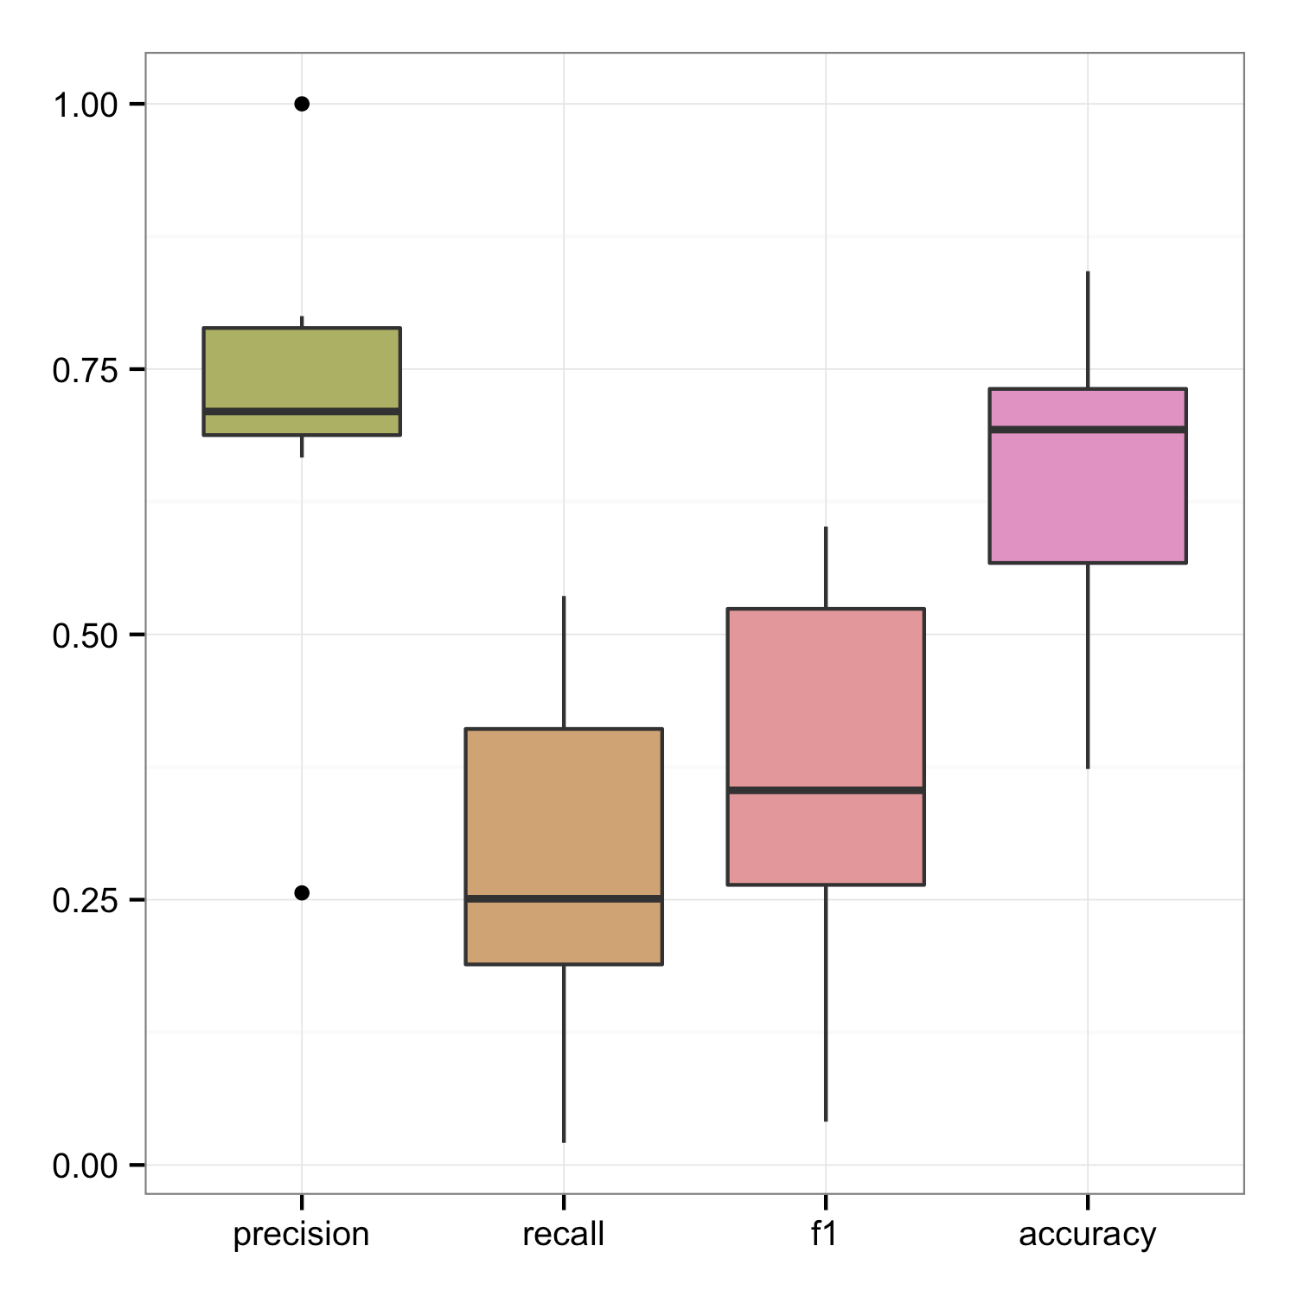

Figure 3: Classification accuracy scores. Although precision scores are relatively high, recall is low suggesting eye movement errors were not detected.

### **Discussion**

In Experiment 1, oculomotor capture occurred on a large number of trials. Many of these trials were classified as “good” by participants, consistent with the general observation of Theeuwes et al (1998) that participants are unaware of their errors. However, the proportion of trials classified as “bad” was higher among “bad” than among “good trial”, suggesting participants were sensitive to some of their errors. Interestingly, even the two authors, who were aware of the motivation for the experiment and the phenomenon of oculmotor capture, did not show a high level of awareness for when they were and were not captured by the distractor. Awareness of distractors and knowledge about the frequency of eye movement errors appears to have little influence in reducing oculomotor capture or increasing eye movement awareness.

# Experiment 2 Pre-registration: Attentional Capture

Attentional capture refers to reflexive and involuntary shifts of attention usually in response to abrupt or unexpected stimuli, and is traditionally observed through reaction times and eye movements, although eye movements do not need to occur for attention to be captured (e.g. Jonides & Yantis, 1988, Theeuwes, Kramer, Hahn & Irwin, 1998). In our first experiment we found that participants were limited in their ability to correctly self-report their eye movements, even with the full knowledge that a distractor would appear. Participants may have been covertly attending the distractor target locations, perhaps as a result of attentional capture due to the abrupt onset of the target or in line with the attentional white bear phenomenon, the distractor location may have been capturing attention in order for it to be successfully inhibited for upcoming eye movements. We aimed to use a paradigm similar to Experiments 1, but to introduce the congruent/incongruent C paradigm used by Theeuwes (1991). Participants were required to executed saccades directly to a target singleton. In no-onset trials we would expect participants to produce the shortest reaction times in order to complete this goal. In onset present trials, if attention is captured, participants should produce longer reaction times as their spatial attention is exogenously allocated to the onset location first. Further evidence for spatial attention will be seen if participants respond slower in incongruent versus congruent trials, referring to the character in the distractor location being the same or different to the discrimination target (DT) shown in the target singleton. We aimed to examine the influence of eye movement awareness on this measure of attentional capture. If it is the case that participants fail to report the error on trials where they look, but do not attend, to the onset, the congruency effect should be diminished on these trials.

### **Methods**

### *Participants*

Sixteen participants (_ females, median age _, range = _ - _ years old, ) took part in the current study.

### *Stimuli and procedure*

The general stimuli and procedure were similar to those used in Experiment 1a and 1b, however to address the question of attentional capture three experimental paradigm elements were changed. 1.) On distractor trials an additional *c* was presented within the distractor target, facing equally forwards or backwards. See Figure 6 for an example. If the sudden onset distractor captured participants attention it is expected that they will be quickest to identify the direction of the target *c* when there is no distractor, slower when the distractor *c* is incongruent with the target *c* and slowest when they are both congruent. 2.) The order of the questions presented at the end of each trial were changed, with participants identifying the direction of the *c* presented within the target circle first, without being prompted by an onscreen question. They were then asked, via an onscreen question, whether they executed a “good eye movement”. 3. Each trial ended when the participant typed in the direction of the target *c* (‘f’ for forwards, ‘b’ for backwards). This allowed us to obtain reaction times which will be used as a measure of attentional capture.

In total the experiment included 577 trials, with half of trials not including a distractor. In distractor trials, the *c* within the distractor was congruent with the discrimination target *c* in the target circle on half of the trials.

### **Results**

Participant’s mean percentage of trials in which they successfully discriminated the perceptual target, a *c* or reversed *c*, presented in the target circle, was 96%. One participant achieved perceptual accuracy of 76% with all other participants correctly identifying the discrimination target on over 94% of trials. Figure 5 shows the number of trials classified as “good” and “bad” for each participant, and within each of these categories the number of trials the participant responded “yes” (good) or “no” (bad). Awareness is looked at individually for all three conditions. Similar to Experiments 1a and 1b, we collapsed over all target and distracter conditions and categorise trials based on the total path length of the saccades made by the participant during the trial. Path length was normalised so that 1 unit represents the distance from the central fixation cross to the center of the target. We then classed trials in which the total path length was between 1-*a* and 1+*a* as “good” (*a*=0.2 unit).

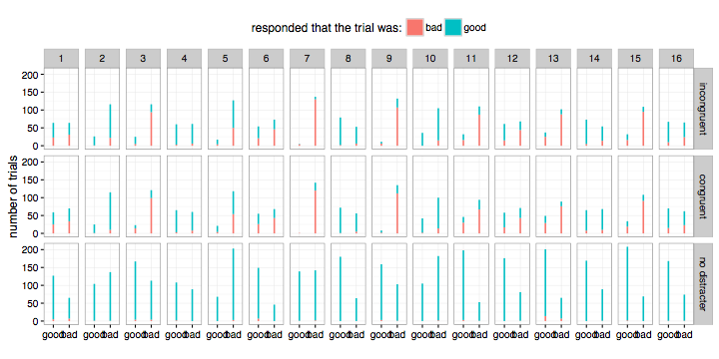

Figure 5: Trials in which “good” and “bad” eye movements were executed by each participant are shown above. Trials in which participants correctly identified as “true”, or incorrectly as “false”, are presented inside the data bars. Performance is looked at across all three conditions.

It can be seen in Figure 5 that participants responded differently regarding eye movement accuracy on no distractor trials compared to distractor trials. Although oculomotor capture occurred on a large proportion of trials within the no distractor condition, with some participants such as participant 2, 5 and 10, producing more erroneous eye movements than correct eye movements, participants continually reported having made correct eye movements to the target colour singleton. Participants were clearly not aware when they made erroneous eye movements in the no distractor trials. Oculomotor capture and eye movement accuracy reports remained relatively consistent across congruent and incongruent within subjects. In general, more incorrect eye movements occurred implying participants’ eye movements were captured by the distractor with many individuals who had previously executed more correct eye movements show large decreases in their movement accuracy within these conditions. Participants who executed more erroneous movements in the no distractor condition continued to display higher incorrect eye movements in distractor conditions. Within the distractor trials, participants who executed more incorrect eye movements in general accurately reported executing more errors however they also generally report more errors in trials that resulted in correct eye movements. This may show some awareness of errors however as these participants also report more correct eye movements as errors, it may be that they are more aware of the incorrect movements they are making on previous trials alternatively they may just show a bias to classify movements as incorrect. As in Experiments 1a and 1b, Figure 5 also shows the individual differences across participants in terms of not only their ability to inhibit the distractor to execute more correct eye movements directly to the target circle but also in self-awareness of their eye-movements.

From the classification accuracy scores presented in Figure 6, it can be seen that participants are showing the lowest accuracy score of all three experiments. Participants have reasonably good precision scores, that is, around 79% of trials that they reported as not good were indeed trials in which they made a saccadic error. However, median recall is much lower (38%) and is very widely dispersed. Participants appear in general to not show much awareness of their eye movements however results show some participants display more awareness than others.

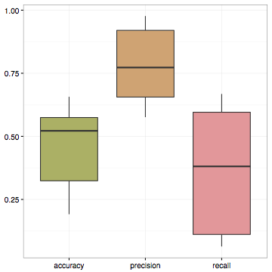

Figure 6: Classification accuracy scores. Although precision scores are relatively high, recall is relatively low with participants showing a large variation in performance.

The range of mean reaction times across all participants in congruent, incongruent and distractor absent trials can be seen in Figure 7. Reaction times were quickest within distractor absent trials, mean RT = 1.1sec (SD = .309ms). Reaction times were on average 318ms longer on distractor trials when the DT in the distractor singleton was congruent with the DT shown in the target circle, RT = 1.418sec (SD = .320ms). Reaction time for trials in which the distractor DT was incongruent to the target DT, produced saccades of 391ms longer than distractor absent trials and 73ms compared to congruent trials, RT = 1.491secs (SD = .335ms).

Figure 7: Box-and-whisker plot showing mean reaction times across all three conditions and the spread of participant reaction times in each condition.

Figure 8 shows the mean reaction time for each condition as well as plotting 95% confidence interval for performance in each condition. As distractor present trials display considerably slower reaction times with little overlap of distractor absent performance it can be determined that attentional capture occurred in both congruent and incongruent distractor conditions.



Figure 8: Mean reaction time taken to identify the DT across all three conditions. Error bars show 95% binomial confidence intervals. Filled dots indicate the mean reaction time for each condition.

### ***Discussion***

Within distractor absent trials participants appeared to show very little or no awareness of eye movement errors. In distractor trials however, participants generally reported more erroneous eye movements than correct and also generally executed more incorrect eye movements. These results are comparable to those found by Belopolsky, Kramer and Theeuwes (2008). In their study they found that participants correctly identified erroneous eye movements in two-thirds of trials when they looked at the distractor however when participants made incorrect eye movements to a circle other than the distractor or colour singleton they were only able to accurately report these movements in 5% of trials. Participants generally show their lowest level of eye movement awareness within this experiment however they also show the largest variation in performance. It was shown that attentional capture occurred within distractor trials. Perhaps as participants’ attention was captured by the distractor this is misinterpreted to represent an erroneous eye movement.

# General Discussion

# References

Yantis, S. (1993) Stimulus-driven attentional capture and attentional

control settings. J. Exp. Psychol. Hum. Percept. Perform. 19, 676–681

Theeuwes, J. (1991a). Cross-dimensional perceptual selectivity. Perception & Psychophysics, 50, 184-193.